
Annual Report
2016-17

Southampton Sight (Southampton Society for the Blind) is a local charity providing a range of practical help and advice to people affected by sight loss, with the aim of promoting independence, wellbeing and choice.
887 people with sight loss supported by Southampton Sight |  |  |  | 38 young people and children attended activities at the centre
52 volunteers gave us 4,325 hours of time equivalent to £31,360
224 social activity sessions |  | 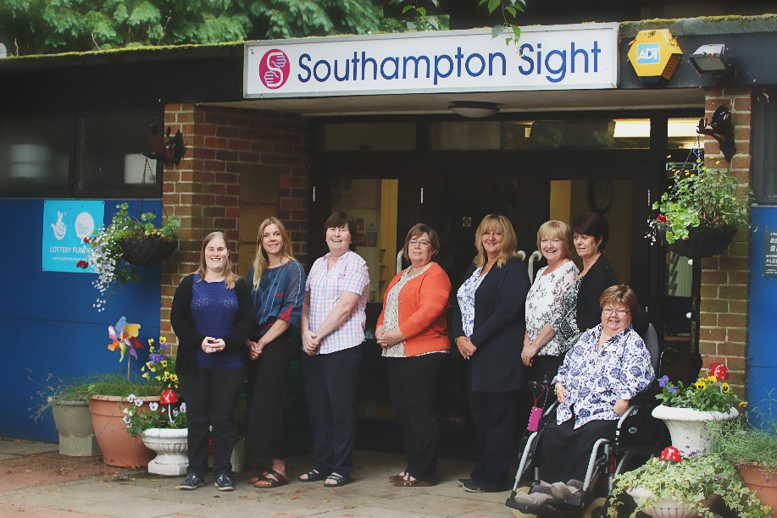 |  |  | 104 people attended assistive technology sessions
15 people accessed the audio library
257 information, advice and equipment demonstrations |  |  |  | 12 activity bulletins and  4 newsletters per annum sent to over 700 members
324 People attended sight loss awareness sessions
“Southampton Sight went the extra mile and did what no one else offered to do. Without their support, I would have struggled and I don’t think I would have got to University.” Student 19 years
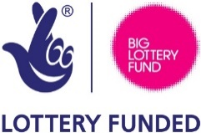
Southampton Society for the Blind 3 Bassett Avenue, Southampton, SO16 7DP
Registered Charity Number 255718 Tel: (023) 8076 9882
www.southamptonsight.org.uk Email: support@southamptonsight.org.uk

“Love coming here and interacting with other people.” Service User July 2017
Southampton Sight Finances
Income £268,976
Investments  £1,799   |  | Legacies  £11,543   |  |  |  | Donations & Gifts  £83,879  
Grants  £123,425   |  | Charitable Activities  £30,832   |  |  |  | Trading  £17,498  
Expenses £204,429
 | Fundraising  £16,922   |  |  | Charitable Activities  £187,922  
Income totalled £268,976 in 2016/17, which was £89,192 higher than the previous year resulting in a surplus of £64,547 (2016 - deficit of £10,612). Reserves totalled £324,030 at the year-end:
General Reserves £187,891
Restricted Funds £ 53,470
Designated Funds £ 82,669 (£52,669 Building Fund and £30,000 Community and Fundraising Developments)
Full accounts published at www.charity-commission.gov.uk
“It’s a sheer delight at Southampton Sight. They do everything to help remove the fright when you have lost or are losing your sight.” Service User July 2017
“The Children’s Group is brilliant - loads of activities and new things for the children to try which has built my confidence as well as my daughters. Thank you.” Parent July 2017
Southampton Sight Objectives
- People with sight loss will have greater independence
- People with sight loss will experience reduced isolation
- People with sight loss will have greater access to information, advice, support and specialist equipment in relation to their sight loss
- Residents of Southampton and associated professionals will have increased awareness of sight loss
Telephone Enquiries
Monday to Friday 9am – 4pm
Friday 9am – 12pm
Resource Centre
Drop in Wednesday 10am – 12pm
Appointments please call the office
Social Activities
Day | Time | Activity
Monday | 11am – 11.45am | Tai Chi
 | 2pm – 4pm | Weekly Social Group
 | 2pm – 4pm | Bridge
Wednesday | 10am – 12pm | Resource Centre drop in
 | 10am – 12pm | People of Working Age Social Group (1st Wednesday of the month)
 | 2pm – 4pm | Weekly Social Group with entertainment
Friday | 10am – 12.30pm | Creative Writing (4th Friday of the month)
 | 1pm – 3pm | Book Group (4th Friday of the month)
 | 11.30am – 2.30pm | Lunch Club (1st and third Friday of the month)
Saturday | 10am – 12pm | Children and Young People (second Saturday of the month)
“I found it useful to see a blind person using IT equipment with confidence which made me feel there is hope for me even though I am older.” Service User July 2017
“I contacted them when I was at a point of desperation and they were very helpful.” Service User July 2017

THANK YOU – We would like to acknowledge the invaluable support we have received over the past year:
Grants & Trusts  Nationwide Building Society  Richard Kirkman Trust  Southampton Charitable Trust  Brunswick Charitable Trust  Hospital Saturday Fund  Weinstock Fund  Charlotte Bonham-Carter Trust  Denplan  Quinton Helping Others Fund  Barker Mill Foundation  Tesco  Rank Foundation  Greggs Foundation  Co-Op Community Fund  Colden Common Choir  Big Lottery Fund Reaching Communities | Chosen Charity  Waitrose Chandlers Ford  Disney Store  Legacies  Alan Broomfield  Vera Margaret Badley  In Memory  Frances Kirkman  Margaret Salter  Jas Thompson  Ronald Gray  Marion Fields  Rita Richards  Robert Painter  Agnes Croxson
Message from the Chief Executive
2016/17 has been a busy year at the Charity as we have seen our activity increase by 70%. This has been largely due to our outreach service which includes befriending, assistive technology demonstrations and sight loss awareness training for Care homes, businesses and community groups. We now face some interesting challenges with our Big Lottery Funding ending in January 2018 which is approximately £80,000 per annum. Our plans are to focus on developing a Low Vision Rehabilitation Hub at the centre which will provide a one stop shop where people newly diagnosed with sight loss will attend their low vision assessments and will also have access to information and advice, a fully equipped resource and equipment facility and access to social and peer support groups. I would like to take this opportunity to thank all our members, volunteers and staff for their ongoing support and look forward to a successful 2017/18.
Jackie Powers (CEO)

“The charity staff have been vital in helping me adapt to my disability and giving me abilities.” Service User July 2017

